**SDBD air plasma source equipped with environmental sensor for application to bacteria inactivation**

M. M. Rashid1, R. Barni1, C. Riccardi1

*1Dipartimento di Fisica G. Occhialini, Università degli Studi di Milano-Bicocca, Milan, Italy.*

**Abstract**

Cylindrical Surface Dielectric Barrier Discharge (SDBD) plasma source was combined with UVC 275 nm and violet 405 nm light sources to produce reactive oxygen and nitrogen species (RONS), for instances, O3 and NO2, for the inactivation airborne microorganism (Escherichia Coli). Duty cycle (DC) of the pulse for the generation of the SDBD plasma was varied from 1~10% and it is found that the O3 and NO2 concentration increased with DC and the concentration solely depends on plasma.

**Introduction**

At this age of biological warfare, the world is facing enormous challenges fighting deadly microbes, for instance, virus, bacteria, fungus and many more which are continuously threatening humans and nature. Covid-19 is a classic example of this, which takes around 7 million life throughout the world. To combat these life threating microbes, a sustainable system must be developed which could act on real environment, for example, in a hospital room, without perturbing the general activities of the particular place. Low temperature plasmas (LTP) is an emerging tool for the inactivation of deadly microbes, for instance, bacteria and virus as they combine high energy electrons, ions and a multitude of free radicals collectively known as RONS (O3, H2O2, NOx, OH etc.)[1]. Surface Dielectric Barrier Discharge (SDBD) plasma is an effective source of LTP have been reported for the depletion of VOC and inactivation of bacteria, fungus, viruses and spores [2]. This study incorporates the ideas of using air and light (UVC and violet) along with Surface Dielectric Barrier Discharge (SDBD) plasma in cylindrical geometry to effectively produce ozone, an efficient disinfectant radical in order to be used as inactivation system for bacteria (E. coli). Ozone is produced as a result of three body collisions as followed in equation (1)

$O+O_{2}+M→O_{3}+M$ (1)

where M could be O2 or N2.

Ultraviolet and violet are two other effective sources for the production of ozone and proven to be useful for the inactivation of deadly microorganism [3, 4]. The effect of all the three sources, SDBD plasma, UVC and violet light are exploited for the production of RONS and estimated with the help of several environmental sensor interfaced through VI (Virtual Instrument) programs written in Labview software. In the following subsections the methodology and result of the investigation will be discussed.

**Materials and Methods**

The schematic diagram of SDBD plasma along with UVC and violet light is shown in figure-1. It consisted of a long tube made with PMMA (Pol Methyl Methacrylate) of length 118 cm and a diameter of 32/35 mm. Inside of the PMMA tube a cylindrical Surface Dielectric Barrier Discharge (SDBD) plasma source has been introduced. The SDBD is composed of a quartz tube of 15 mm diameter and 160 mm length where grid type copper electrodes were placed outside and inside of the same tube. A DC source (12 V and 0.40 A) to produce the pulses was employed in conjunction with a direct current (DC) fan (5V) to flow the air in order to generate the SDBD plasma (right most side of the schematic diagram). A metal oxide semiconductor Field Effect Transistor (MOSFET) driven high voltage transformer was used to generate the plasma discharge. The duty cycle (DC) of the pulse were varied from 1~10 % for the effective production of RONS within the system. Along with SDBD air plasma, two varieties of light sources were inserted inside the PMMA tube. Three UVC light sources of 275nm wavelength were placed in between the SDBD plasma source and single violet light source of 405nm wavelength to exploit the efficacy of the system to produce reactive oxygen and nitrogen species (RONS). The UV and violet light source were drive by line voltage (220V and 50 Hz).Two different environmental sensor assembly (DF Robot for ozone and MiCS-4514 for nitrite) were used in order to measure the concentration of RONS (O3 and NO2). Both the sensors were interfaced through VI (virtual instrument) program written in the Labview software. The sensors were placed on the left side at the opening of the PMMA tube.

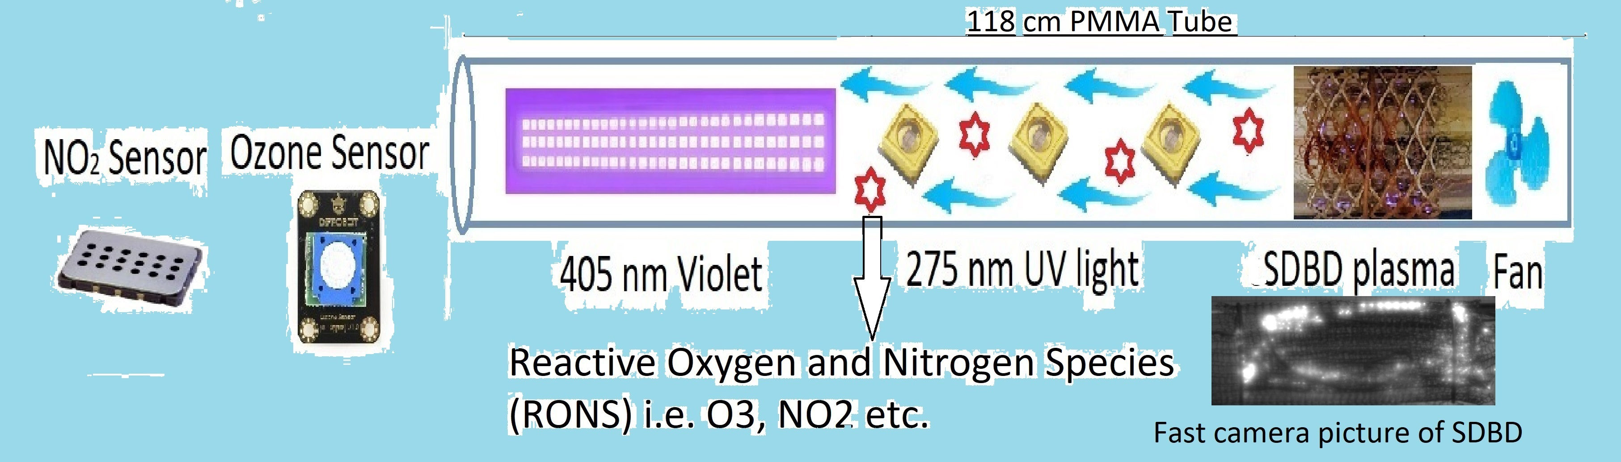

Figure-1: Schematic diagram of SDBD plasma and dual-wavelength light sources (UVC-275nm and Violet 405nm) interfaced with environmental sensors for the inactivation of bacteria.

The electrical characterization was done by a digital storage oscilloscope (RS PRO RSDS1304CFL 4 channel 300 MHz) along with high voltage and current probe. The optical data was recorded by AvaSpec-ULS4096CL-EVO spectrometer of resolution 0.3 nm and wavelength of 200-1100 nm range.

**Results and Discussion**

Electrical characterization of the SDBD plasma source was performed by measuring the voltage and current flowing the system and the graph shown in figure 2 illustrate the relation between voltage and current flow the SDBD plasma source. The estimated absorbed power by the plasma was 9 watt. The optical emission spectra (OES) represented in figure-3 depicts the species produced in SDBD plasma source. The OES data yielded the nitrogen second positive system (SPS) $N_{2}(C^{2}Π_{u}-B^{3}Π_{g})$ in the wavelength range 280-390 nm and first negative system (FNS) $N_{2}^{+}(B^{2}{Σ_{ }}_{u}^{+}-X^{2}{Σ_{ }}_{g}^{+})$ in the wavelength range 391-405 nm.



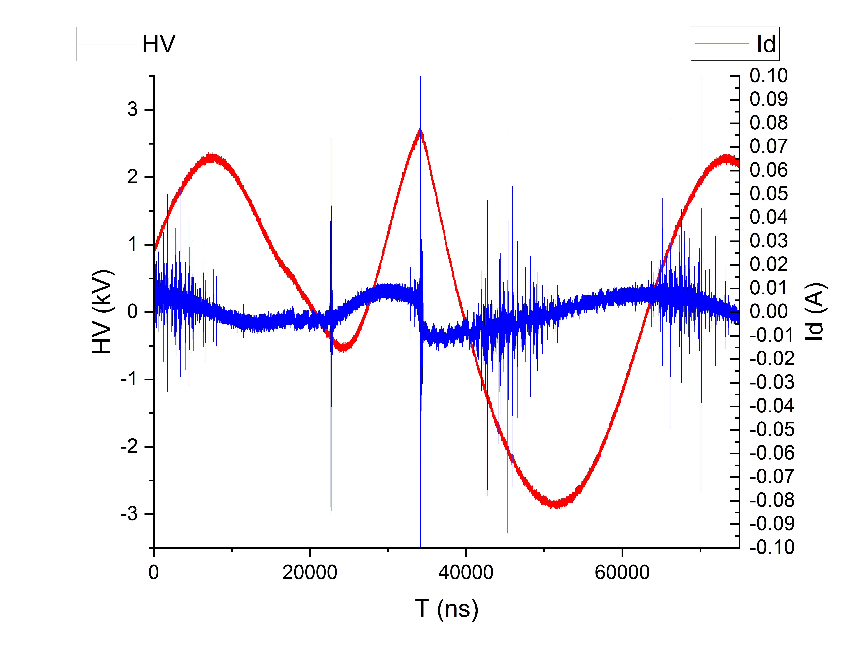

Figure-3: Optical emission spectroscopic (OES) data of the SDBD plasma source





Figure-2: V-I characteristics of the SDBD plasma source

Figure-5: Nitrite concentration as a function of duty cycle (DC) variation on various events (Plasma, UV, violet light on-off).

Figure-4: Ozone concentration as a function of duty cycle (DC) variation on various events (Plasma, UV, violet light on-off).

The ozone (O3) and nitrite (NO2) concentration as function of duty cycle (DC) at various events (UVC, violet and plasma on-off time) are represented in figure 4 and 5 respectively. On first event, when the fan was turned on where the ozone concentrations dropped down a bit and continue to dropping even when the UVC and violet lights are on. Afterwards, when the SDBD plasma was turned on the ozone concentration started to reach the peak value at 80 ppb, 85 ppb, 125 ppb and 200 ppb for 1%, 2%, 5% and 10% of duty cycle of the pulse respectively. On the first cycle the combined effect of all three sources are presented followed by turning off the UVC and plasma leaving the violet source on where the ozone concentration drops down again. It reaches to peak value again when the plasma was turned on. In both cycle the concentrations are nearly same for all the duty cycle used for the experiments. The similar effect are observed in the case of NO2 reaching peak values of 0.5 ppm, 0.9 ppm, 1 ppm 1.1 ppm for 1%, 2%, 5% and 10% of duty cycle of the pulse respectively. It is clear that, the concentration of RONS (O3 and NO2) varies as a function of duty cycle (DC) and the main role player is the cylindrical Surface Dielectric Discharge (SDBD) air plasma source.

**Conclusion**

A long tube plasma apparatus with ultraviolet and violet light source has been designed and investigated for the production of reactive oxygen and nitrogen species (RONS) in order to abate microorganism such as bacteria (Escherichia Coli). Duty cycle (DC) of the pulse for the generation of plasma inside the tube were varied and RONS (i.e. O3 and NO2) concentration were found to increase and future work is devoted to control the level of O3 and NO2 below the threshold level (0.1 ppm and 0.5 ppm respectively) as well as to inactivate the airborne microorganism.

**Acknowledgements**

This work has been funded by the National Plan for NRRP Complementary Investments (PNC, established with the decree-low 6 May 2021, n.59, converted by law n. 101 of 2021) in the call for the funding of research initiatives for technologies and innovative trajectories in the health and care sectors (Directorial Decree n. 931 of 06-06-2022) – project n. PNC0000003-AdvanNced Technologies for Human-centrEd Medicine (project acronym: ANTHEM). Thanks to the company Artemide in the person of the President and CEO Arch. Carlotta de Bevilacqua and the technical team that collaborates on the project ANTHEM "Wide spectrum light and devices for sanitation analyses" composed by Andrea Gallucci, Laura Pessoni, Silvia Marinoni and Roberto Franzosi.

**References**

[1] C. Piferi et al. Appl. Sci. 2022, 12, 4253 (2022).

[2] C. Piferi et al. Cleaner Engineering and Technology, Volume 8, 2022,

[3] Pierotti, G., Piferi, C., Popoli, A., Plasma Sources Science and Technology, 2023, 32(6), 064005.

[4] Biganzoli I., Barni R., Riccardi C., 2013, Journal of Physics D: Applied Physics, 46 (2), 025201